create table Users(User_Id int primary key,Username varchar(20) not null,Email varchar(20) unique not null,Phone_No int unique not null);

desc Users;

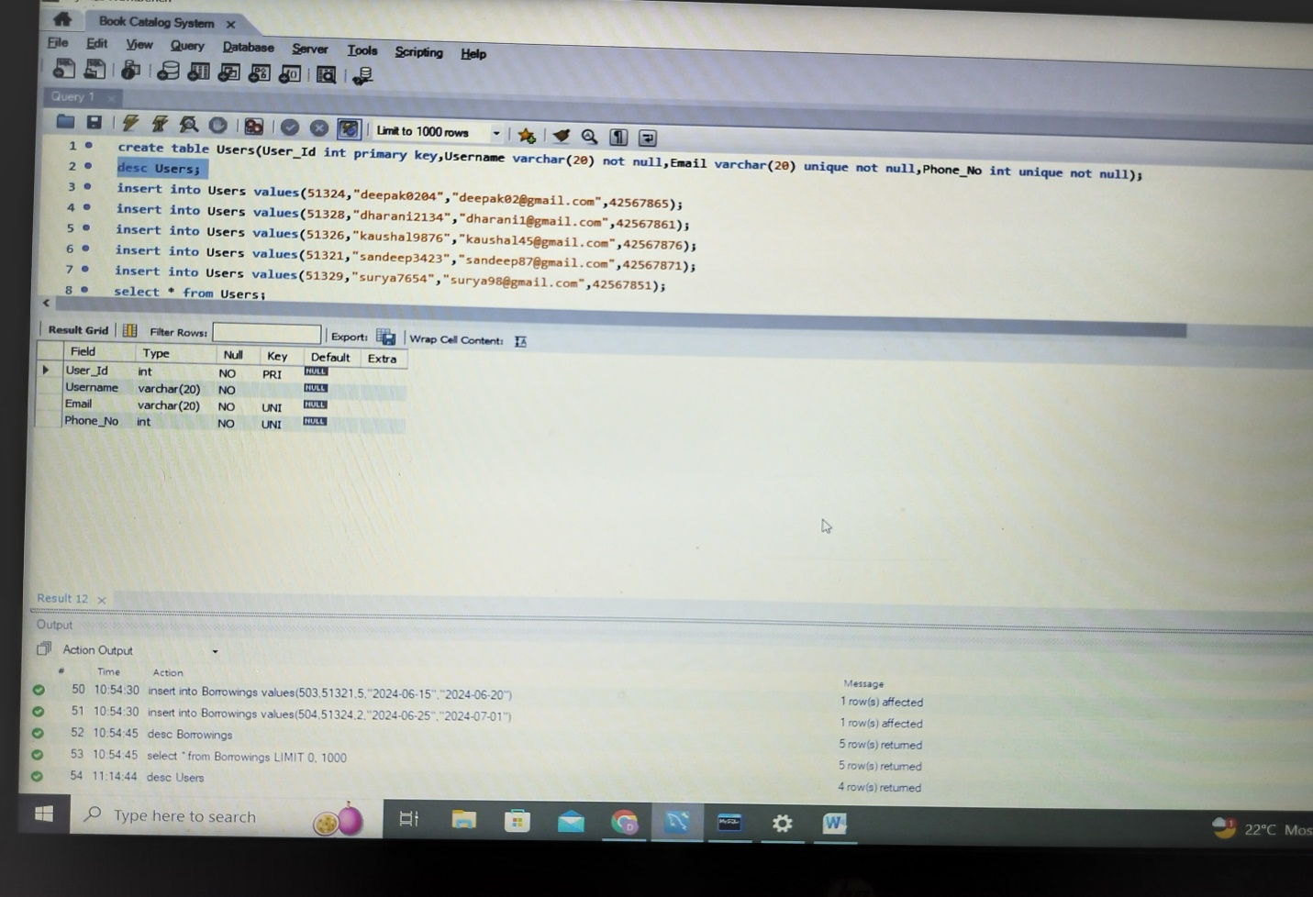

insert into Users values(51324,"deepak0204","deepak02@gmail.com",42567865);

insert into Users values(51328,"dharani2134","dharani1@gmail.com",42567861);

insert into Users values(51326,"kaushal9876","kaushal45@gmail.com",42567876);

insert into Users values(51321,"sandeep3423","sandeep87@gmail.com",42567871);

insert into Users values(51329,"surya7654","surya98@gmail.com",42567851);

select * from Users;

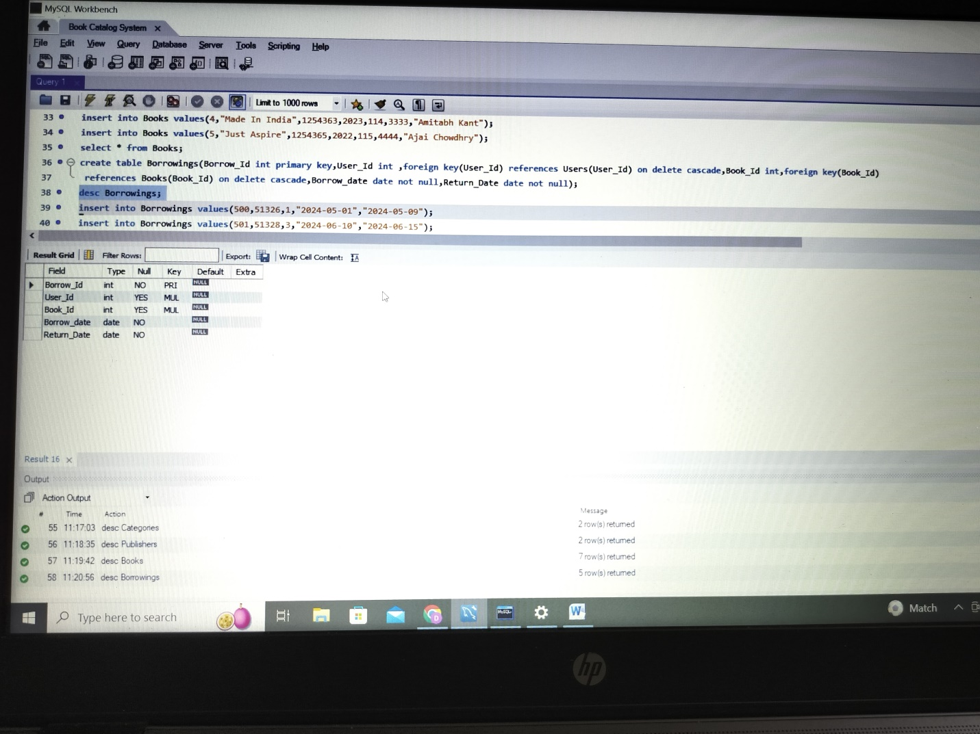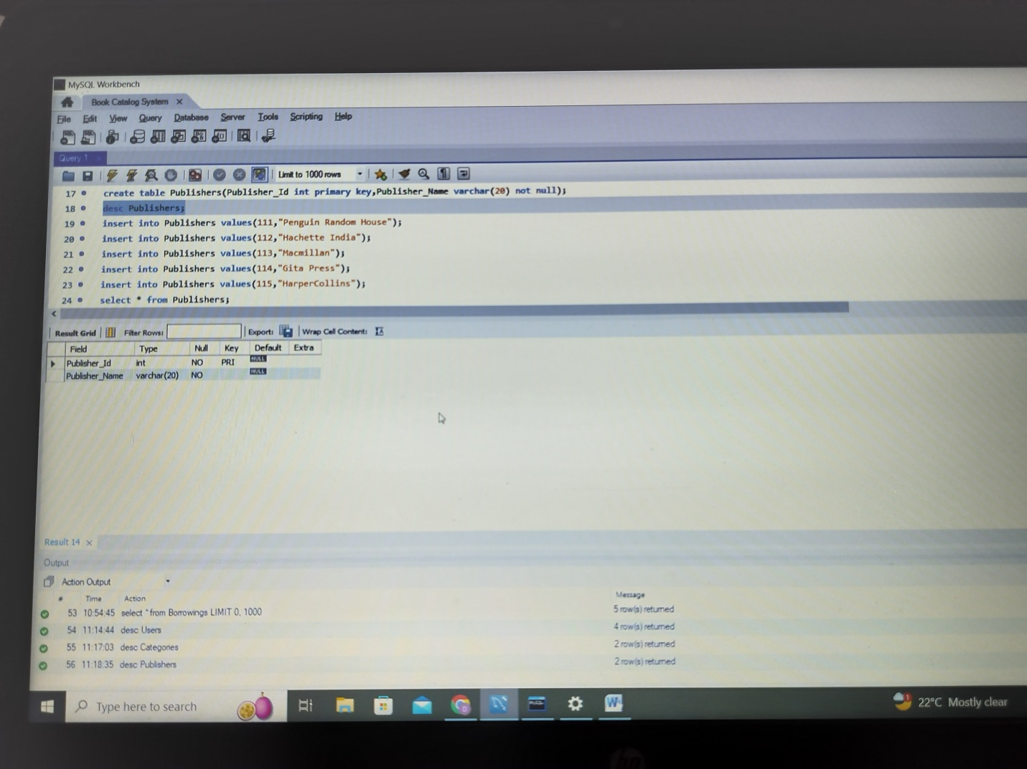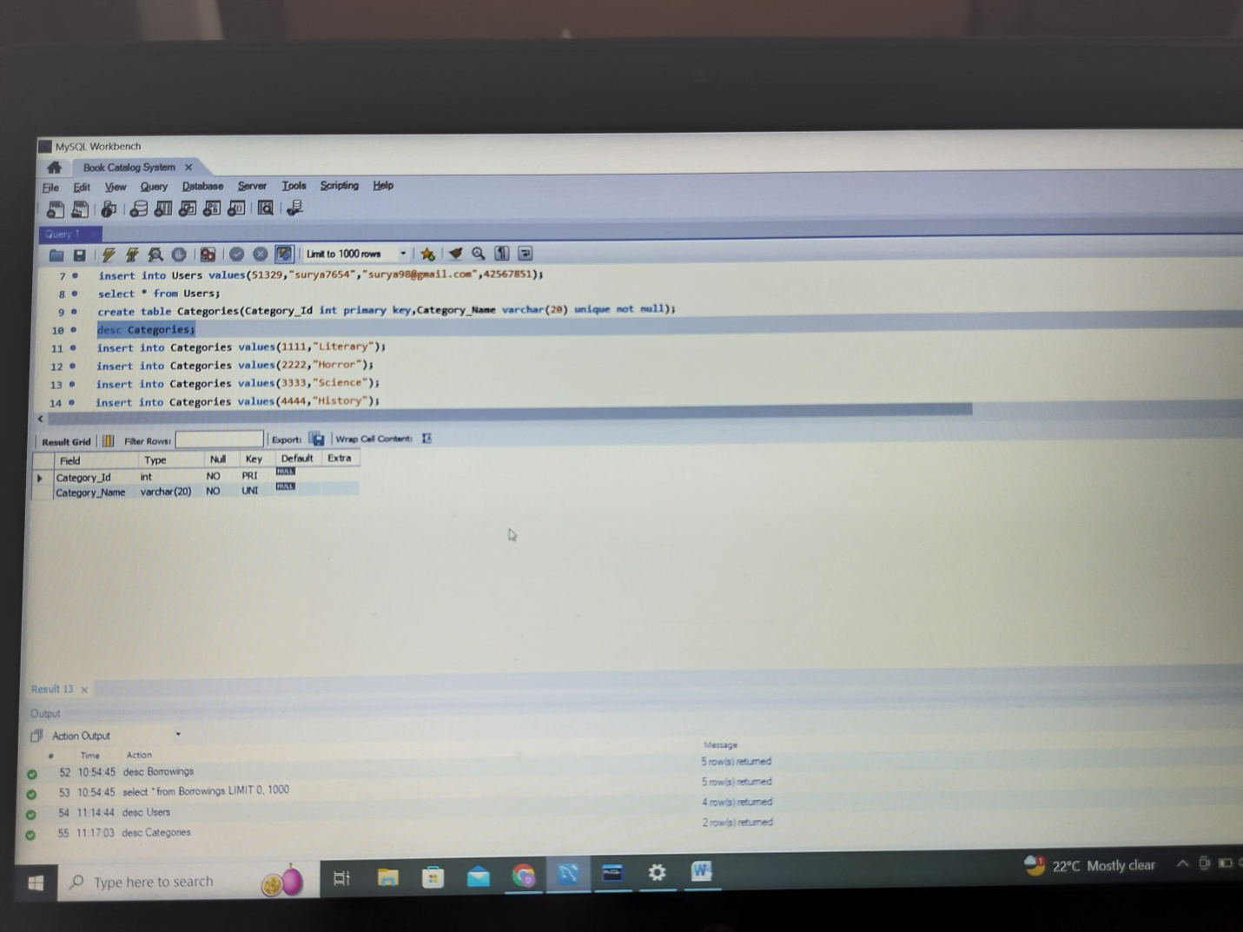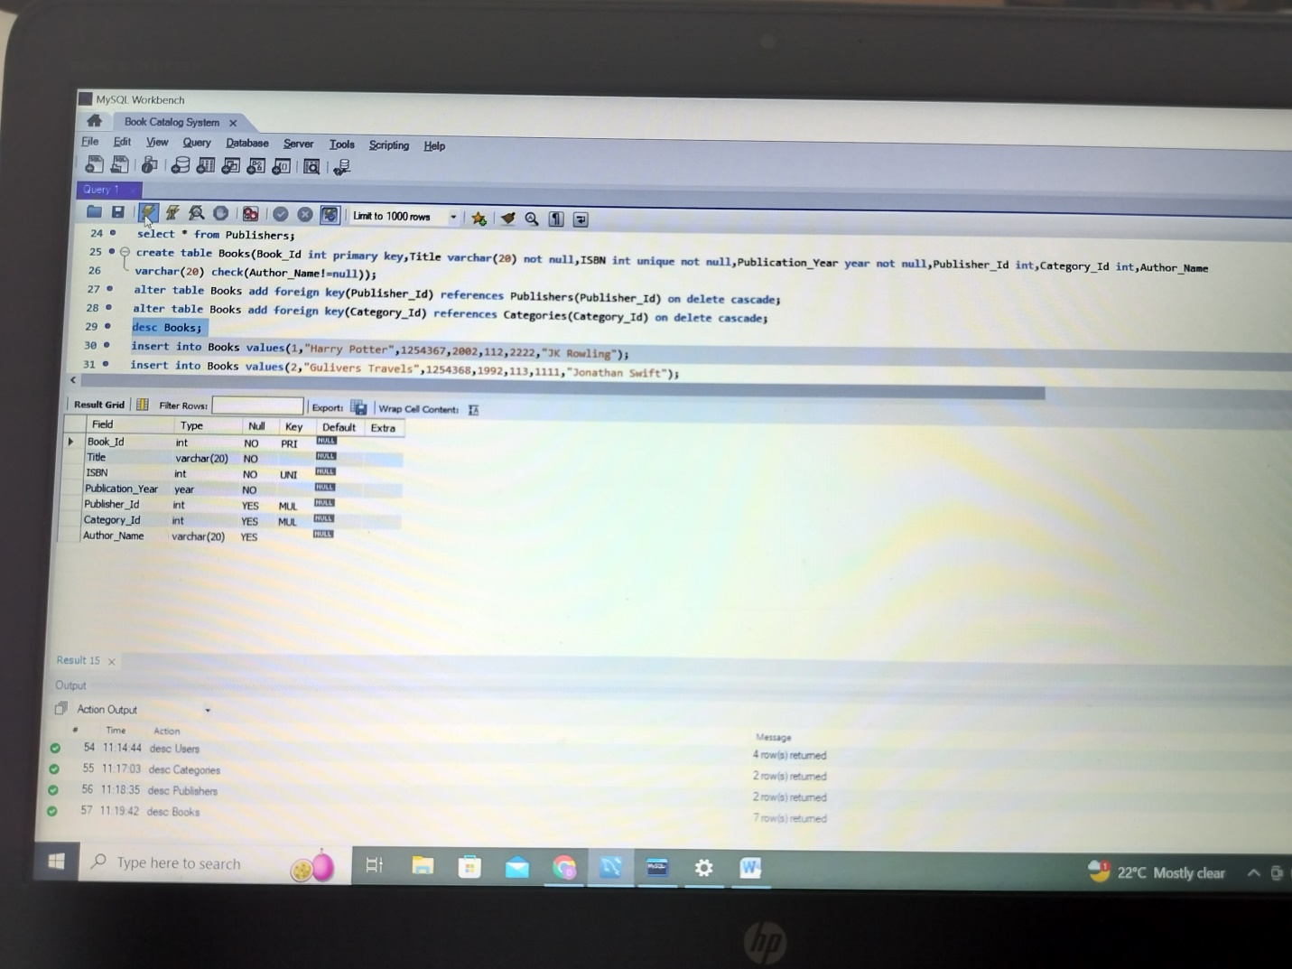

insert into Users values(51324,"deepak0204","deepak02@gmail.com",42567865);

insert into Users values(51328,"dharani2134","dharani1@gmail.com",42567861);

insert into Users values(51326,"kaushal9876","kaushal45@gmail.com",42567876);

insert into Users values(51321,"sandeep3423","sandeep87@gmail.com",42567871);

insert into Users values(51329,"surya7654","surya98@gmail.com",42567851);

select * from Users;

